***Lab Activity***

Name: Rumaisa Fatima

Class: Se-5B

Roll: Se-221076

Course: Computer Networks  
  
  
  
  
  
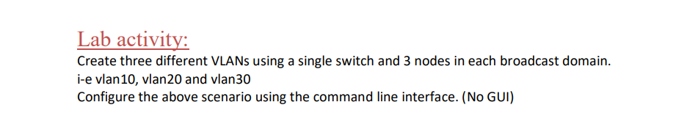

Step 1: Set up the activity structure with one switch and nine PCs.  
  
  
  
  
  
  
  
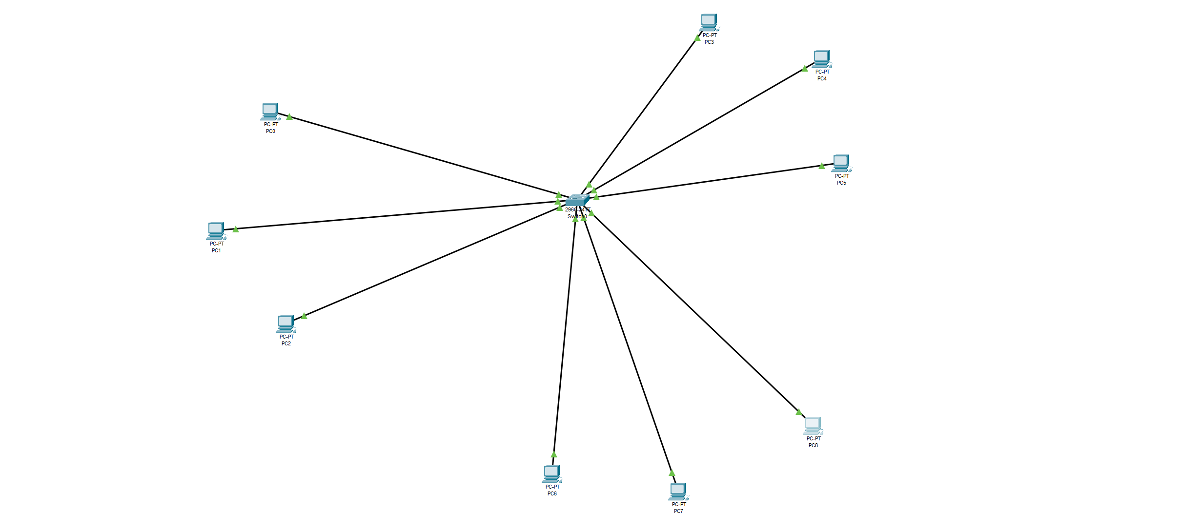  
  
  
  
  
  
  
  
  
  
  
  
  
  
  
  
Step 2: Add colors through draw ellipse and Notes to label the devices with their IPs and VLANs.  
  
  
  
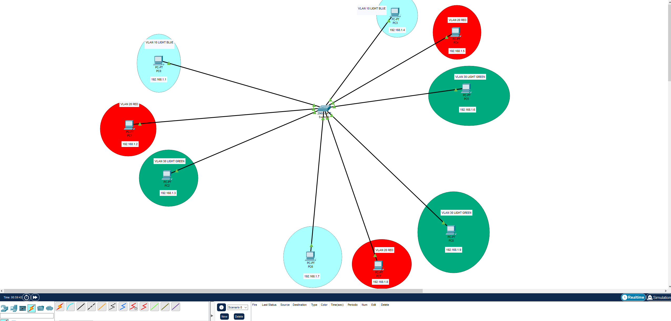

Step 3: Assign IPs to each of the nine PCs, for example, PC0 to 192.168.1.1, PC1 to 192.168.1.2, and so on. Access PC0, go to IP configuration, and set the IP address.

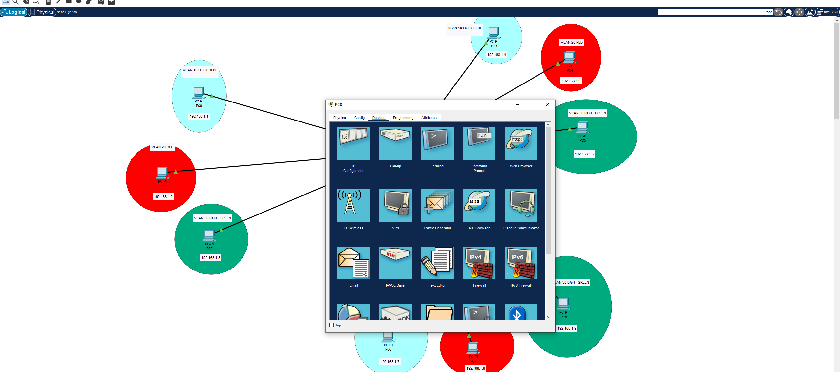

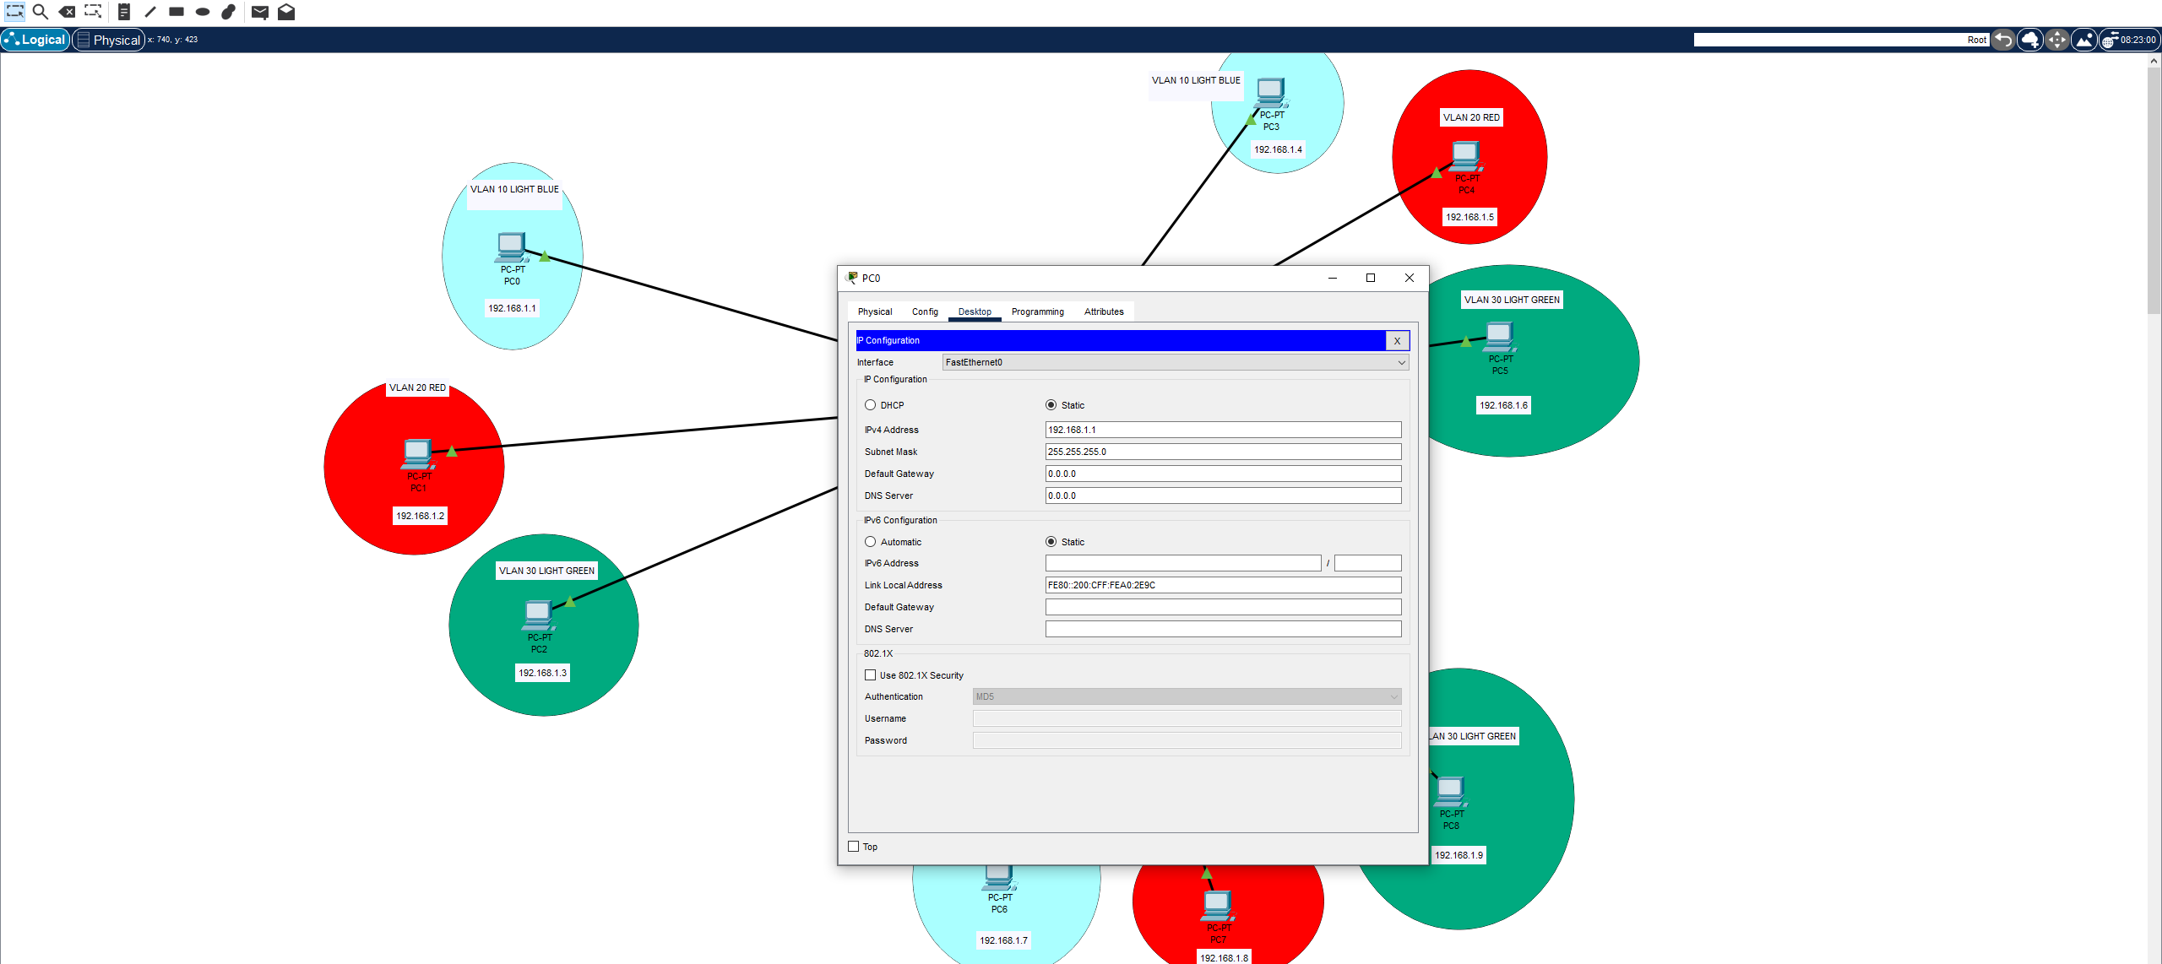  
  
  
  
  
  
  
  
  
Step 4: Enter global configuration mode, create VLANs, and assign names (e.g., VLAN 10, VLAN 20, VLAN 30). Click the switch, open the CLI, enter the commands, and verify with the command show vlan brief.  
  
  
  
  
  
  
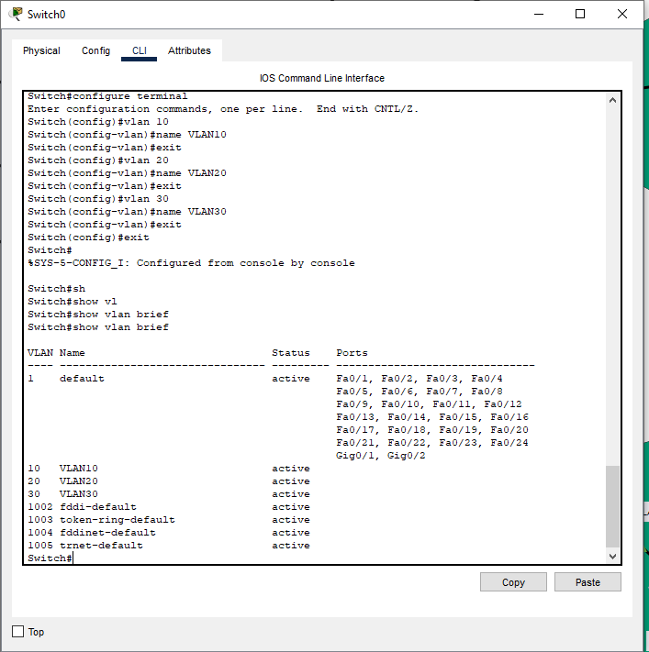  
  
  
  
  
  
  
  
  
  
Step 5: Assign the switch ports to their respective VLANs.  
  
  
  
  
***For VLAN 10 (VLAN10), assign Fast Ethernet ports 0/3, 0/4, and 0/7 to the VLAN.  
  
  
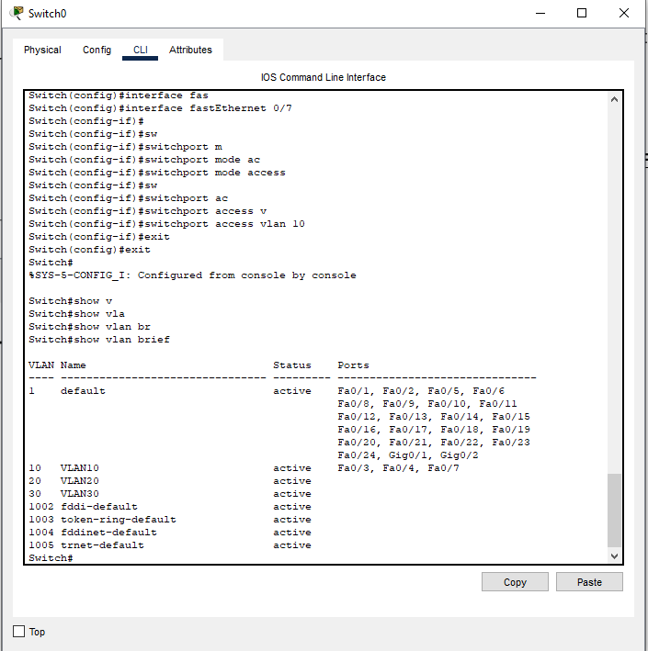  
  
  
  
  
  
  
  
  
  
For VLAN 20 (VLAN20), assign Fast Ethernet ports 0/2, 0/5, and 0/8 to the VLAN.***

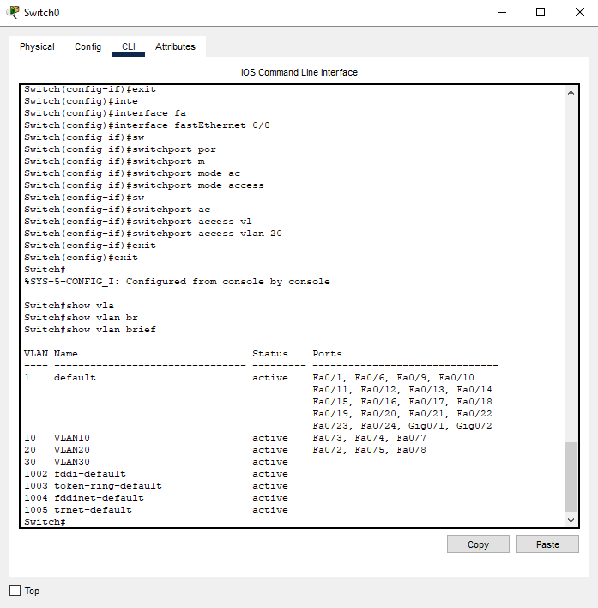  
  
  
  
  
  
  
  
***For VLAN 30 (VLAN30), assign Fast Ethernet ports 0/1, 0/6, and 0/9 to the VLAN.  
  
  
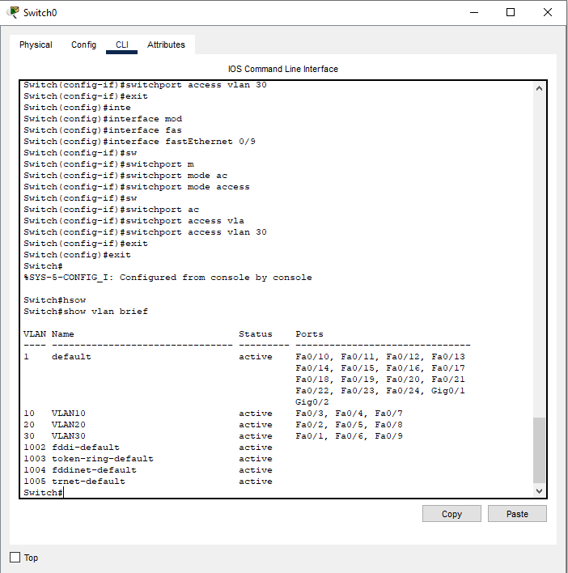***  
  
  
  
  
  
  
  
  
  
  
  
Step 6: Verify the setup by sending some packets to test connectivity.  
  
  
  
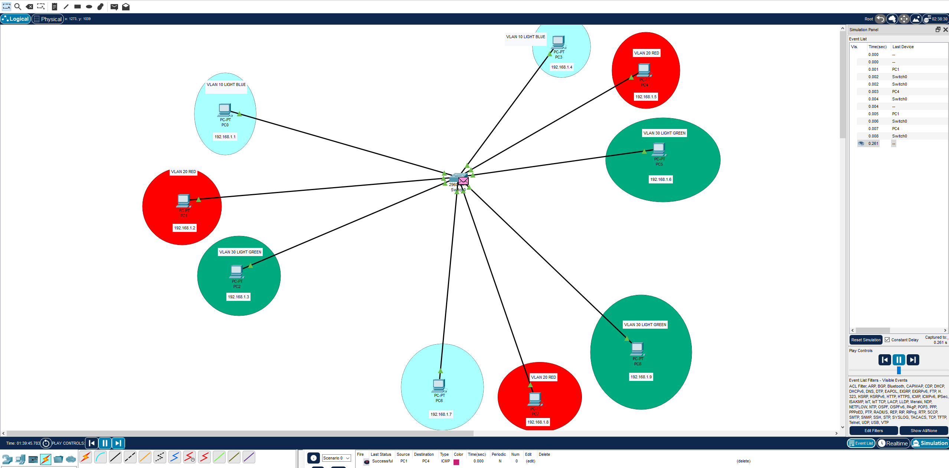  
  
  
***As you can see, the packet was successfully sent, confirming the setup is correct.***